**Date of the Progress Review**

|  |
| --- |
| 10/11/2023 |

.

**Summary Dashboard**

|  |  |  |  |
| --- | --- | --- | --- |
| **Schedule On** | | **Budget**   **On** | |
| **Planned work** | **Planned work is done** | **Actual Cost $** | **$3,025** |
| **Actual work** | **Design/prototype-100%**  **Functionality-80%** | **Remaining Cost $** | **$2,900** |
| **% work complete** | **65%** | **Baseline Cost $** | **$0.00** |
| **Remaining work** | **35%** | **Variance $** | **$5,925.00** |

(Record in the dashboard the relevant information to enable accurate reporting of actual performance against both planned work complete (schedule) and planned costs incurred (budget).

Information to go in the summary dashboard can be acquired from MS Project after updating % of tasks completed, and duration / timing of task completion - see: MS Project> Reports> Dashboard> CostOverview )

**Project Progress to date**

The project is up-to speed and has occurred no difficulties, it has been running on budget the entire time with work being finished at or just ahead of schedule. The Team has been collaborating well and has been completing tasks that are prerequisites for team members first to increase work flow

**Product Status**

( complete the table below, deleting any functions that are not applicable to your project and list other functions that are within scope for your project)

|  |  |  |  |  |  |
| --- | --- | --- | --- | --- | --- |
| **Functions** | **Proportion of function completed %** | Compliance with IT works coding standards (%) | Compliance with website security requirements (%) | Compliance with website Accessibility requirements (%) | Comments (optional) |
| Server-side: |  |  |  |  |  |
| * Connect to Database | 100% | 100% | 100% | 100% |  |
| * Register | 100% | 100% | 100% | 100% |  |
| * Login | 100% | 100% | 100% | 100% |  |
| * Display products | 100% | 100% | 100% | 100% |  |
| * Search products | 50% | 50% | 0% | 50% | Structure is there but needs to be implemented |
| * Add to cart | 100% | 100% | 100% | 100% |  |
| * View Cart | 20% | 100% | 100% | 100% |  |
| * Remove from cart | 20% | 100% | 100% | 100% | Button is there but not implemented |
| * Checkout | 0% | 0% | 0% | 0% | Checkout and payment processing hasn’t started |
| Client Side: |  |  |  |  | There are no client side aspects of the website as everything was done effectively in PHP |

**Project Status**

Record relevant information as at the reporting date identifying both the schedule and budget baseline data measured against actual performance and budget to-date. Justify any variations between planned and actual results and the corrective actions (if required).

Current completion status is at 65% with around 90% of the coding complete and only the checkout needing finalisation, but that is in track with the schedule. The cost is also on budget with no issues needing to be mentioned.

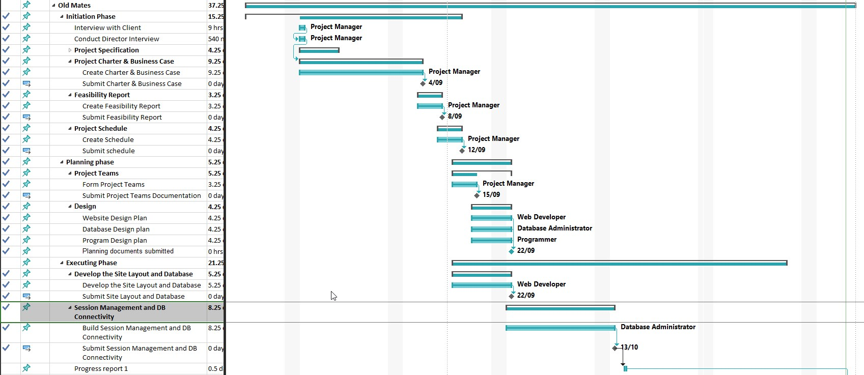

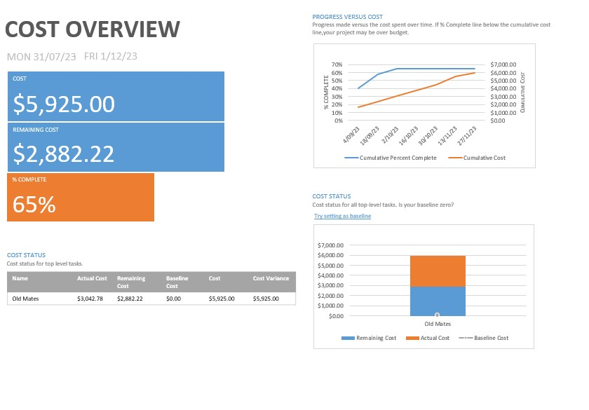

**Risks and Issues**

Update the risk assessment to reflect current risk situation

|  |  |  |  |  |
| --- | --- | --- | --- | --- |
|  | Risk | Status: Active  Dormant  Retired | Risk Monitoring Method | Risk Mitigation or Corrective Action taken during the reporting period [Comment required for active risks] |
| R1 | Project runs behind schedule | Active | Monitored through scheduling tool | Monitor Project Schedule and follow up with team members on any issues |
| R2 | Project runs over budget | Active | Monitored through scheduling tool | Monitor Project Schedule and ensure tasks are done on time |
| R3 | Client's expectations are set too high | Dormant | Monitored through regular client meetings |  |
| R4 | Sponsors / client disengage | Dormant | Monitored through regular client meetings |  |
| R5 | Unexpected Scope changes | Active | Monitored through Product Status & Project Change request | Monitor any change requests from client, ensure all expectations are understood, fill out change request form |
| R6 | Team member falls ill / unavailable | Dormant | Monitored through team meetings and team communications |  |
| R7 | Team members leave | Dormant | Monitored through team meetings and team communications |  |
| R8 | Team interaction and performance is below expectations | Dormant | Monitored through team meetings and Product status and scheduling tool |  |

**Completion**

The current progress has been going as expected, the website is to be expected to be finished by end of week, there are no expected risks or delays with this last push to the finish, any proposed changes can be added if more time and budget is allocated. We will start on other documentation to speed up the rest of the schedule.

**Updates**

Record confirmation the following documents have been amended in line with the Progress report.

* Project Schedule
* Project Change Request

Submission documents for this assessment:

* + Report Template must be used
  + Submissions include:
    - Progress Report
    - An Updated Project Schedule